ELECTRICAL AND ELECTRONICS ENGINEERING
Vision
To be an excellent centre for the fundamental education in the field of Electrical &
Electronics Engineering and to reach the needs of industry, academia and community.
Mission
- M1: To provide quality education in the area of Electrical & Electronics Engineering for increasing the opportunities in higher education & employment by giving the best practice of teaching-learning process.
- M2: To impart the value-based system of education by providing professional ethics & good communication skills to meet the challenges in the society.
- M3: To provide practical knowledge to students by collaborating with industry, research organizations and academia to encourage creativity and innovation.
Program Educational Objectives Statements
- Graduates will pursue higher education.
- Graduates will have successful career opportunities in Electrical & Electronics industries and other institutions.
- Graduates will exhibit leadership qualities with professional ethics for the development of society.
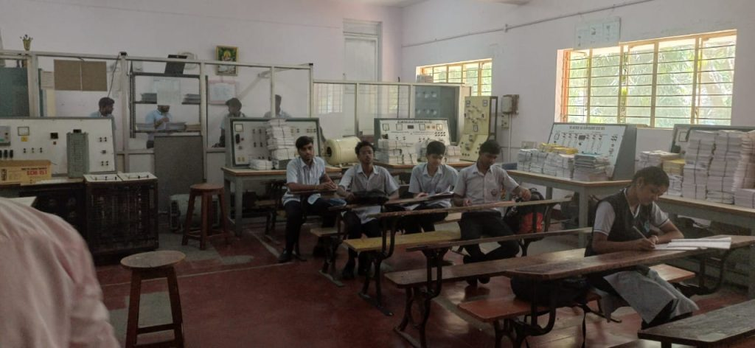
FROM HOD’S DESK
- Electrical and Electronics Engineering programme was established in the year 2007- 08, recognised by DTE, Bengaluru and affiliated to AICTE, New Delhi. The current intake is 40 students.
- The department has well qualified and experienced teaching faculty.
- The core courses of Electrical and Electronics Engineering programme offers a variety of opportunities to the aspirants be it for securing employment or to grow as an entrepreneur.
- At the end of the course, the students will be able to apply the knowledge acquired to identify, design/ redesign and solve Engineering problems.
- Many students are either employees of prestigious organisations like L&T, TRIPHASE Technology, Asian Paints, ABB, Toyota Kirloskar, Wipro or pursuing their higher studies in coveted institutions, like RVCE, SJCE, NIE.
- Staff and students are provided with unlimited free internet access at e-Library during spare time, so that they can develop and enhance their knowledge acquired in class rooms.

LIST OF TEACHING FACULTY

SL No. | Image | NAME | DESIGNATION | QUALIFICATION | Date of Joining | PROFILE
1 | 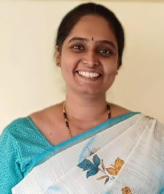 | Prathibha.B | HOD | MTech | 01-01-2009 | click here
2 | 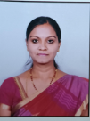 | Sadhana M.V | Lecturer | MTech | 01-01-2010 | click here to view
3 |  | Sneha. S | Lecturer | MTech | 29/7/2010 | click here to view
4 | 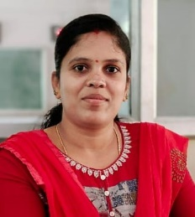 | Shwetha. M.P | Lecturer | MTech | 28/2/2011 | click here to view the profile
5 | 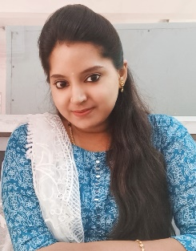 | Vidya | Lecturer | BE | 01-10-2023 | click here to view

LIST OF SUPPORTING STAFF
SL No. | Image | NAME | DESIGNATION | QUALIFICATION
1 |  | Madhusudhan N B | Instructor | BE
2 |  | Ravi S K | Mechanic | ITI
3 |  | Somashekara A N | Helper | ITI
4 | 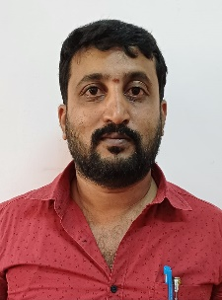 | Prashanth H S | Helper | ITI

